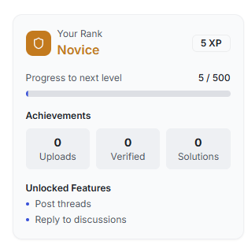

**we have to add , a article with link , oping new page showing how user can level up and also i**mporve the UI make the ui compact , more informative professional , simple, any thing relvevant ,

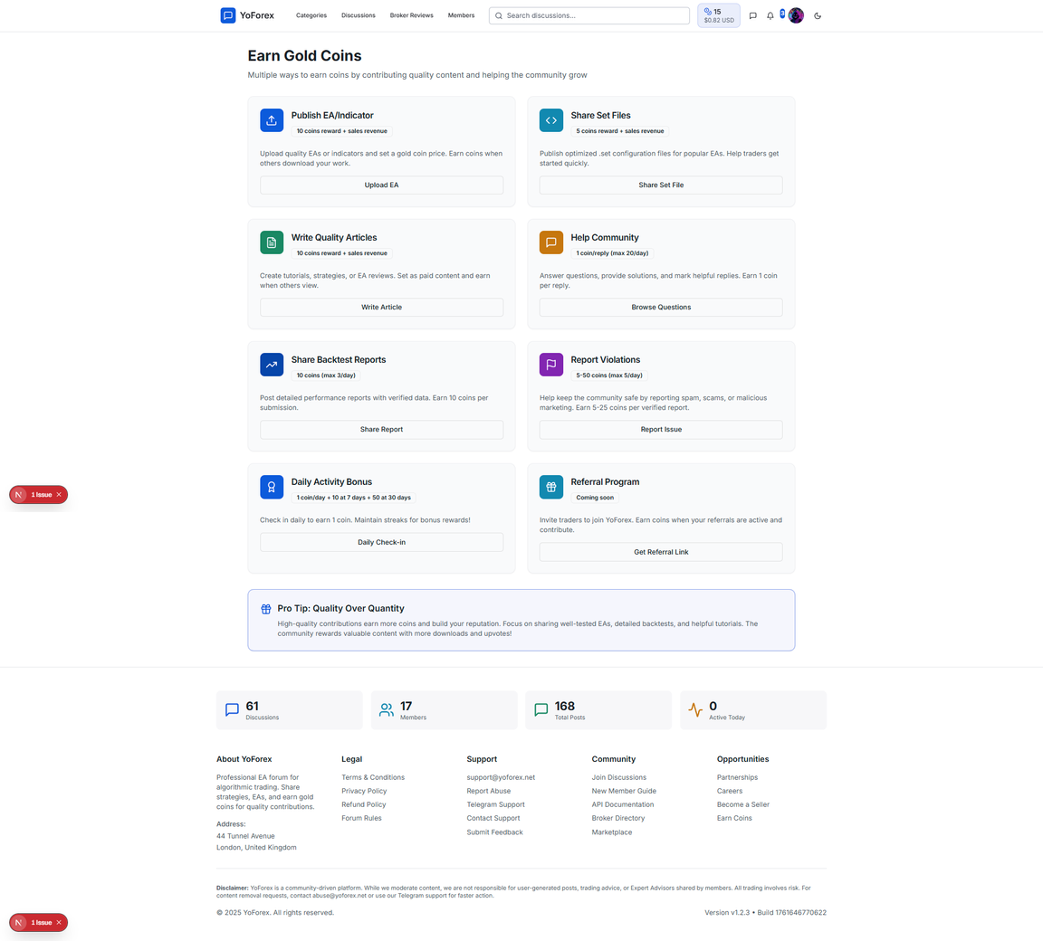

we have to improve the UI and made it user friednly and easy to understand and simple understandble , instead of giving buttons add links of articles that how user can earn explain them if you want you can create images for that articles too and link them and make sure you route properly and if you want you can share the links

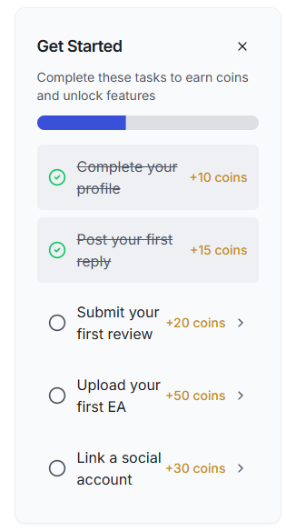

imporve the UI make the ui compact , more informative professional , simple, any thing relvevant ,

3a31727ca5346106a2cf1dc14e99e404.png

notification not working in homepage

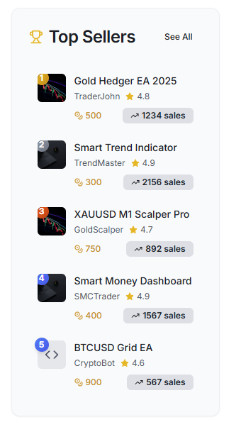

**i**mporve the UI make the ui compact , more informative professional , simple, any thing relvevant you can add it make sure all apis and algorithim are working correctly

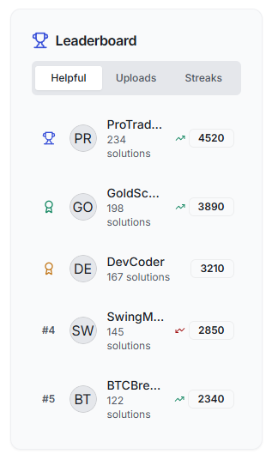

**i**mporve the UI make the ui compact , more informative professional , simple, any thing relvevant you can add it make sure all apis and algorithim are working correctly

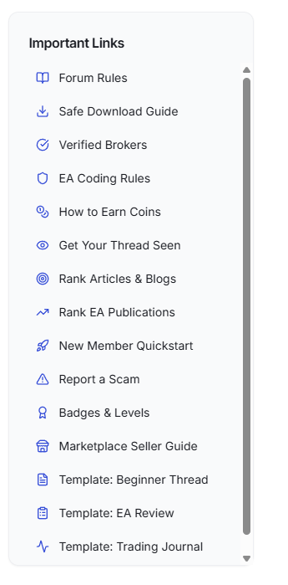

when clicking showing 404 error on every links please check  



same 404 errors on every links

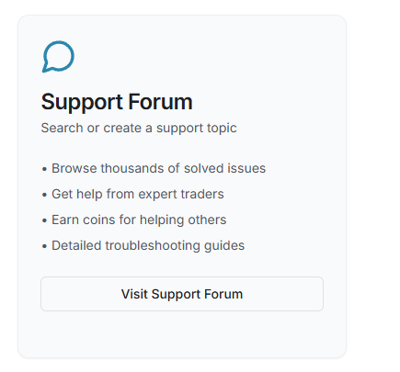

when clicking showing category not found

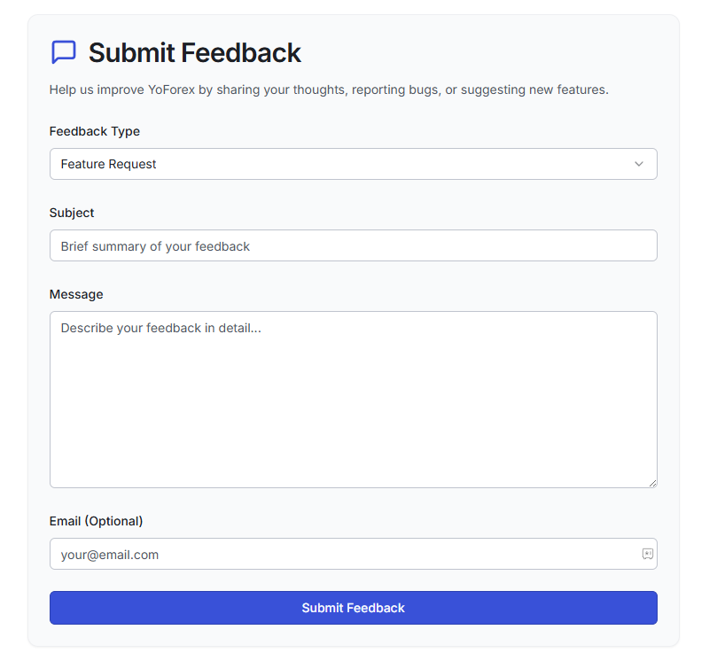

submitting feed back shows nothing

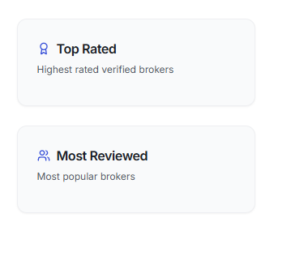

clicking not working

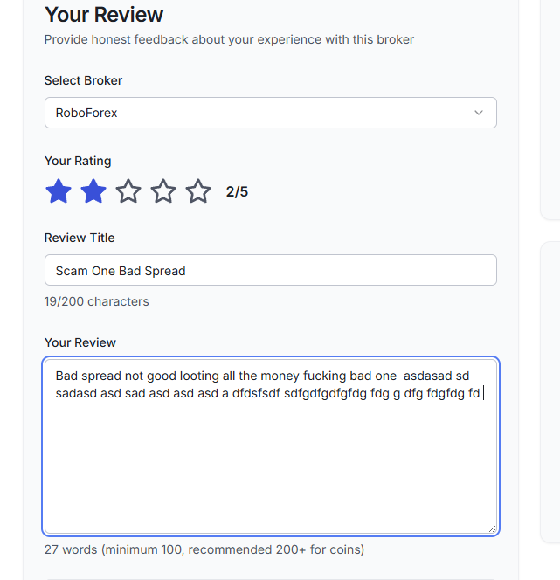

the count in words but i want in per word count when i put space then it counting as a word please check  

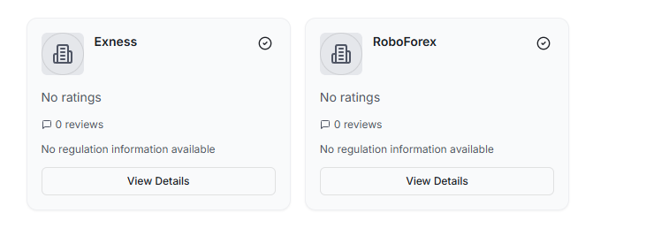

can you create a api or something like that it should fetch the logo of this broker automatically and place it here and when user type to add the broker , after 2 or 3 words of typing he should get the suggestions i dont knwo can you add it  